Tech Fauna Global.

business proposal 2

For Independent Contractors
Prepared by:
Cleopatra Tayeta
Gmail: ST10533635@RCCONNECT.EDU.ZA
Contact No: 0788144980

TABLE OF CONTENTS
1.ORGANISATION Overview 3
2. Website Goals and Objectives 3
5. Design and User Experience 4
6. Technical Requirements 5
7. Timeline and Milestones 6
8. Budget 6
9. References 6

1.ORGANISATION Overview
Name: Tech Fauna Global
Organisation type: Small Business
Brief History: Tech Fauna Global is a small business that develops and supplies smart technology for monitoring animals. The company provides products such as GPS collars, Radio Frequency Identification tags and trap sensors for farmers, game reserves and pet owners. Its aim is to help customers track and protect animals using reliable and affordable technology.
Mission: To provide affordable and reliable animal monitoring technology that helps farmers, conservation organisations and pet owners care for and protect animals.
Vision: To become a trusted supplier of animal tracking technology by offering high-quality products and excellent customer service.
Target Audience: Farmers and livestock owners, game reserve managers, pet owners and small agricultural cooperatives.

2. Website Goals and Objectives
- Generate qualified leads and online product enquiries for the device catalogue.
- Build trust and credibility as a small but specialised technology supplier.
- Provide clear product information and pricing to reduce pre-sale support queries.
Key Performance Indicators (KPIs):
- Number of product enquiries submitted through the contact/enquiry form.
- Average time spent on product pages (engagement).
- Conversion rate of site visitors to enquiry submissions.
3. Current Website Analysis
TechFauna Global does not currently have a dedicated website and mainly relies on social media to communicate with customers. This makes it difficult for customers to compare products or find detailed information. A professional website will improve the company's online presence and make it easier for customers to learn about its products and services.
4. Proposed Website Features and Functionality
- Homepage: Hero showcase of flagship products, a short value proposition, and featured product highlights.
- Products: Catalogue of devices (GPS collars, RFID tags, camera-trap sensors) with descriptions and specifications.
- Services: Custom fitting, bulk-order, and after-sales support information.
- About Us: Company background, team, and credibility markers (experience, partners).
- Contact / Enquiry: Enquiry form for product and pricing questions, plus a map showing more than one service location.

5. Design and User Experience
- Colour Scheme: Tech teal paired with a signal-orange accent for calls-to-action, reflecting a blend of technology and the outdoors.
- Typography: A modern sans-serif for a professional, technology forward feel, with strong contrast for outdoor/mobile readability.
- Layout and Design: Product-card grid layout on the homepage and catalogue, prioritising quick scanning and comparison.
User Experience Considerations:
- Product-first navigation so customers can browse the catalogue within one or two clicks.
- Responsive design, since many farm/reserve customers will browse on mobile in the field.
- Prominent, low-friction enquiry form to convert interest into leads.

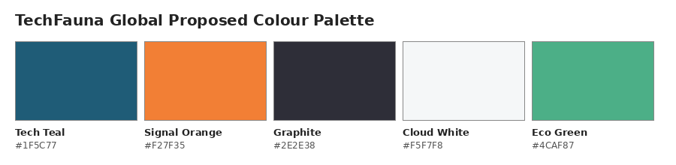
Figure 1 — color palette for TechFauna Global.
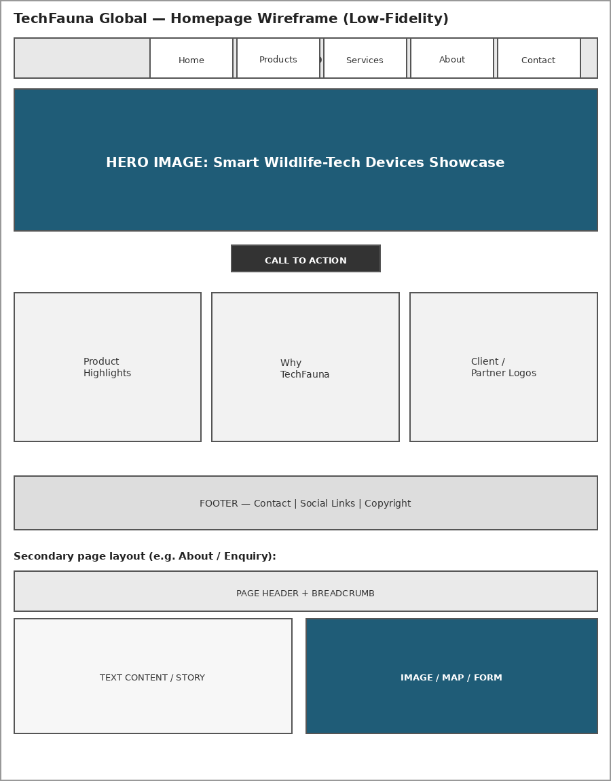
Figure 1.1 -Low-fidelity wireframe: homepage and secondary page layout for TechFauna Global.

6. Technical Requirements
- Hosting: standard shared business hosting with room to grow into e-commerce later.
- Domain: techfauna.co.za.
- Languages/Frameworks: HTML5, CSS3 and JavaScript for Part 1–3 of this module; static catalogue approach with potential future e-commerce integration.

7. Timeline and Milestones
WEEK | MILESTONE | DELIVER
Week 1 | Approval of proposal & content research | Approved proposal, product content/images
Week 2 | Sitemap & file/folder structure finalised | Sitemap diagram, folder structure
Week 3 | HTML structure for all 5 pages built | Initial HTML files pushed to GitHub
Week 4 | Navigation linked & product content integrated | Fully linked, content-complete site
Week 5 | Testing, debugging & README finalised | Final Part 1 submission

8. Budget

Item | Estimated Cost (ZAR) | Estimated Cost (ZAR)
Domain registration | Annual.co.za domain registration | R150 – R250
Hosting | Shared business hosting (small-business tier) | R700 – R1 200 / year
Product photography/assets | Original photos of existing devices (owned by business) | R0 (in-house)
Maintenance | Periodic catalogue updates (est. per year) | R800
Total (Year 1, estimate) |  | R1 650 – R2 250

9. References
FAO. (2021) Digital Technologies in Agriculture and Rural Areas. Available at: https://www.fao.org/ (Accessed: 5 August 2026).
National Livestock Identification Association. (2023) RFID Technology in Livestock Management. Available at: https://www.nlis.com.au/ (Accessed: 5 August 2026).
Adobe. (2024) Adobe Color. Available at: https://color.adobe.com/ (Accessed: 5 August 2026).
Figma. (2024) Figma: Collaborative Interface Design Tool. Available at: https://www.figma.com/ (Accessed: 5 August 2026).
Google. (2024) Material Design 3. Available at: https://m3.material.io/ (Accessed: 5 August 2026).
MDN Web Docs. (2024) HTML: HyperText Markup Language. Available at: https://developer.mozilla.org/en-US/docs/Web/HTML (Accessed: 5 August 2026).
MDN Web Docs. (2024) CSS: Cascading Style Sheets. Available at: https://developer.mozilla.org/en-US/docs/Web/CSS (Accessed: 5 August 2026).
Nielsen Norman Group. (2024) 10 Usability Heuristics for User Interface Design. Available at: https://www.nngroup.com/articles/ten-usability-heuristics/ (Accessed: 5 August 2026).
OpenAI. (2026) ChatGPT. Available at: https://chat.openai.com/ (Accessed: 5 August 2026).
World Wide Web Consortium (W3C). (2024) Web Content Accessibility Guidelines (WCAG) Overview. Available at: https://www.w3.org/WAI/standards-guidelines/wcag/ (Accessed: 5 August 2026).
World Wide Web Consortium (W3C). (2024) HTML Standard. Available at: https://html.spec.whatwg.org/ (Accessed: 5 August 2026).

